Real-time Abnormal detection for Intent-Based Energy Reduction

Run the Project:
- Run bash entrypoint.sh in the terminal of the main folder, this will start the containers and the kafka producer and the consumer to get the data and do feature selection then data cleaning
- From the Spark/prediction_to_influx_tables folder open a new terminal Then, run the desired pipeline
Example: python3 kmeans_predict_to_influx_.py
- Login to Grafana to visualize the results by this URL http://localhost:3000
Grafana credentials:
  - username: admin
  - password: admin
  - Connection URL to influxdb: http://influxdb:8086 or http://localhost:8086
  - DB name: iber

Architecture:

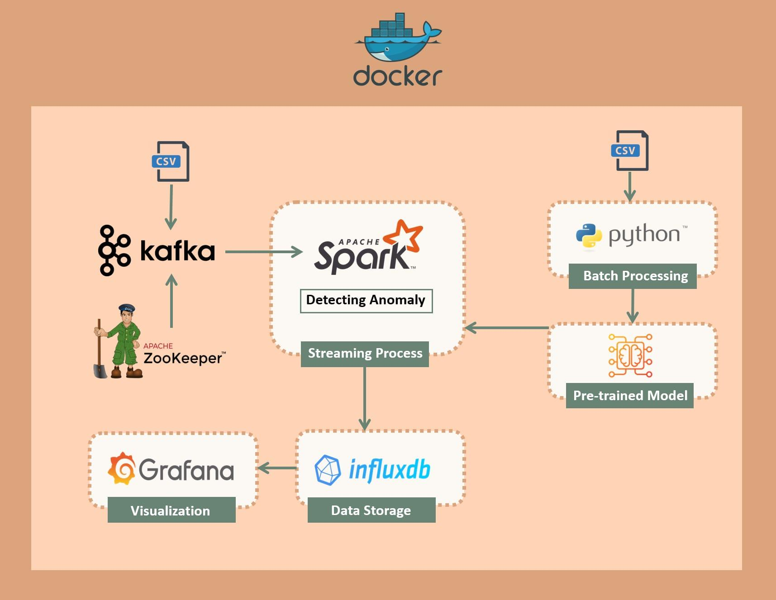
Detecting Abnormal

To upload the use the grafana dashboard follow these steps :
1-
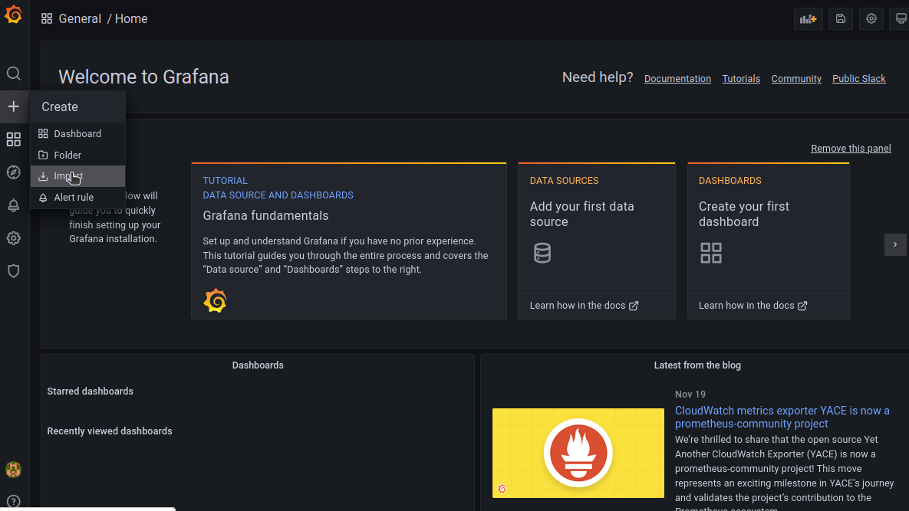
2-
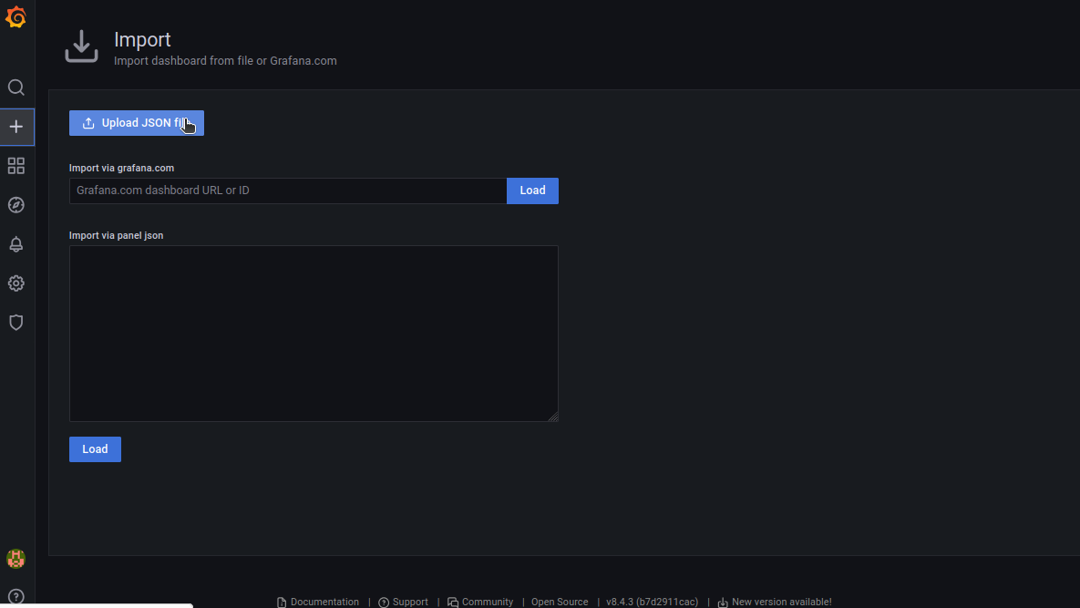
3- then choose the json file for the dashboard you want in grafana folder for example : Zone-Specific Analysis.json

4-
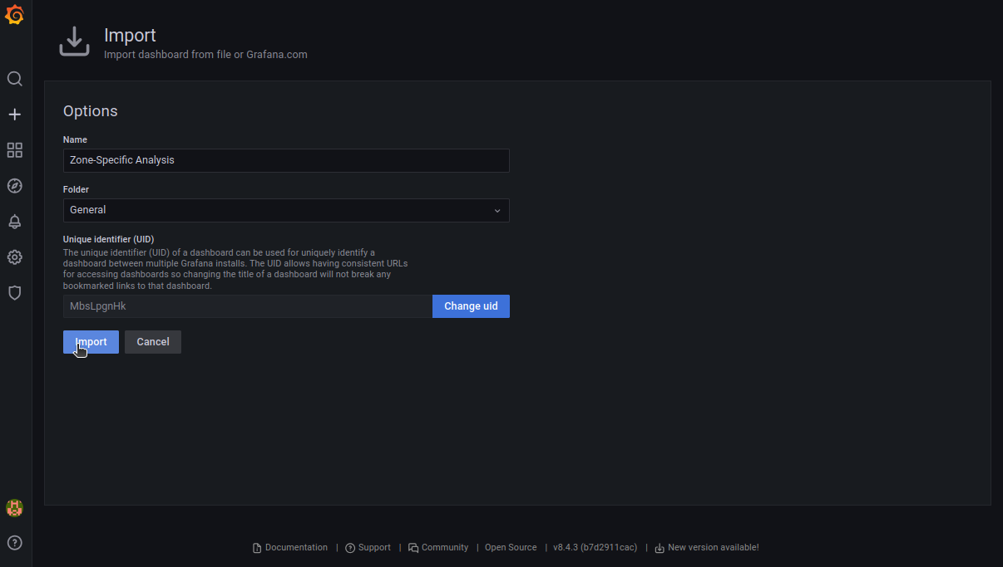
then it’s uploaded successfully

